# **Influence of Gender on Consumer Buying Patterns**

Student Name –

ID number –

Understanding the unique ways factors affect customer purchase behaviours stands essential in consumer behaviour analysis fields. This analysis draws its data from a simulation that contains customer demographic alongside behavioural information. The dataset includes five key attributes which are age and gender along with income and spending score as well as purchase frequency numbers.

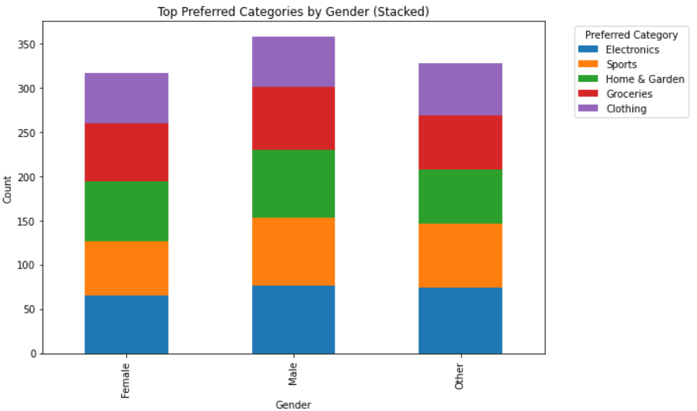

The stacked bar chart reveals which products female consumers buy and male consumers buy including demographic-specific buying habits. All gender groups demonstrate comparable shopping patterns as they buy most from the categories of Home & Garden and Groceries and Clothing. Consumer preference seems to focus away from Electronics and Sports among all other product categories. Consumer purchasing decisions seem to be unaffected by gender specifically so much that they might stem from other elements like economic activities and lifestyle choices. The equal proportions within the data help demonstrate that purchasing activity shows consistent trends across gender groups within each category which indicates obtaining products may be significantly influenced by economic needs rather than gender-specific requirements.

A detailed evaluation of consumer patterns emerges from analysing the spending score statistics collected in the data. The distribution of spending scores extends from 1 to 100 revealing substantial variability because the average score stands at 50.69 yet the variation between scores amounts to 28.96. Customer spending habits show wide variations because certain consumers consistently outspend additional groups of consumers.

|  |  |
| --- | --- |
| **Metric** | **Value** |
| Count | 1000 |
| Mean | 50.685 |
| Standard Deviation | 28.955175 |
| Min | 1 |
| 25% | 26 |
| 50% (Median) | 50 |
| 75% | 76 |
| Max | 100 |

The scatter plot built around the functionality of age and spending score illustrate there is no clear correlation in this dataset between the age and spending score, which indicate that those two are most likely independent to each other. Whilst age and gender didn’t have such a strong determiner, but as data points were scattered randomly, it becomes very obvious.

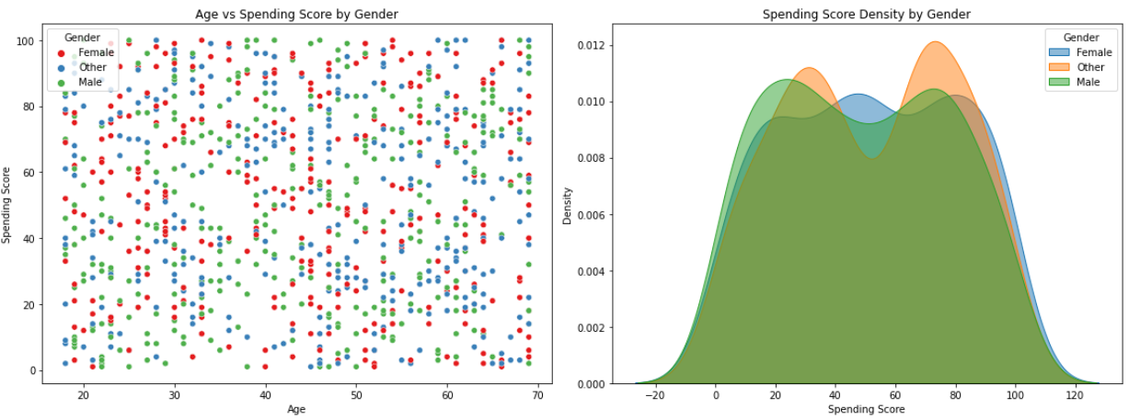

On the other hand, density plot depicts spending patterns by different categories in more detailed manner. The Female category displays the Higher density lower spending scores, the spending score in dataset women are spend less than others genders, who have peak at higher spending scores. On the other hand, however, the Male category shows a more uniform distribution, which suggests their spending behaviour more consistent in most of all. In addition to the general impact of gender on spending, it is apparent from the "Other" gender category that a small set of differences do exist, but the effects are far smaller than other factors.

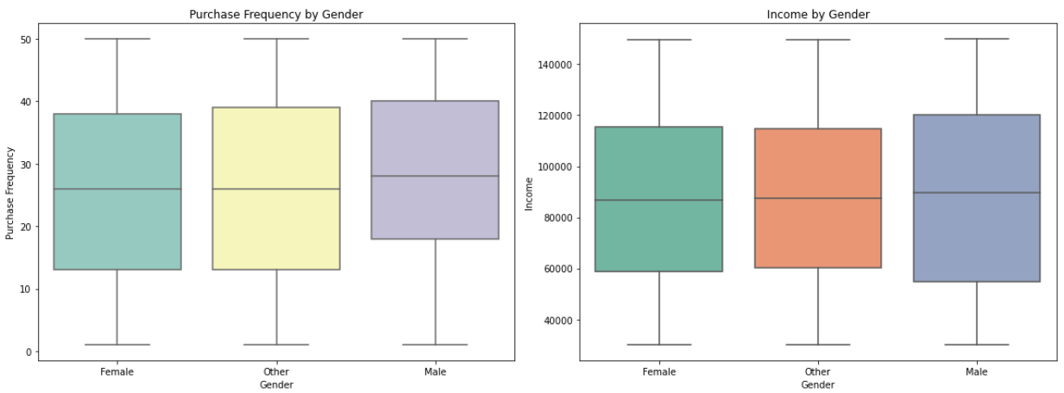

More insights can be gained about income and purchase frequency with the use of box plots. Analysis shows that purchase frequency also differs much by little (median ≈ 30) indicating that men, women and other gender groups actually visit the stores at similar rates. The variation is very slight due to income. The median income of females in the dataset is close to about 90,000 USD, or higher than the median income of men and those identifying as other genders.

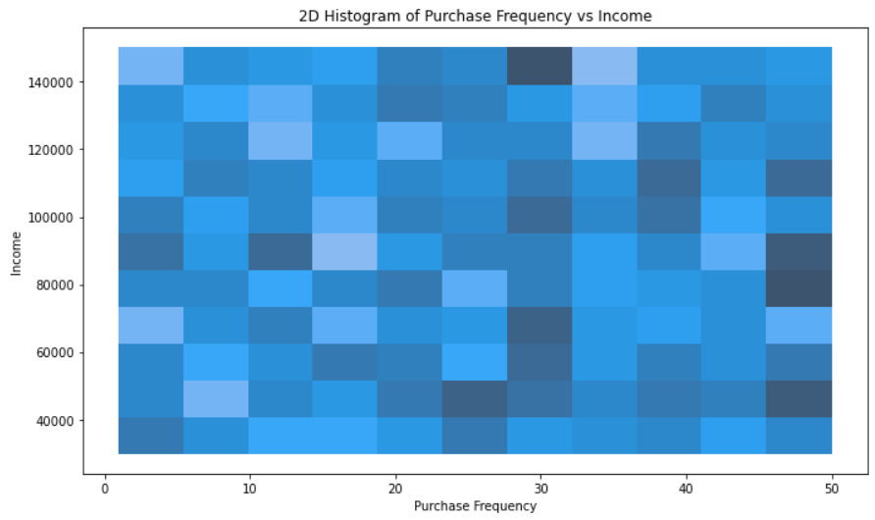

Lastly, the 2d histogram showing the relation of income and purchase frequency reveals some interesting trend. It appears to have a fairly high concentration of customers in the middle-income bracket who do tend to shop more often, however the higher incomes do not directly correlate with a higher purchase frequency. It means income cannot solely determine how often the person will shop, and also there are various consumer segments with diverging spending behaviours that regardless of the income level will exist.